

ALI RAZA
BSCS
9864
COAL-A

LAB NO 03

TASK N 01:

- The constant values 60000h, 80000h, and 20000h are in hexadecimal. Guess and write the values of the EAX register in the above program after the add and sub (subtract) instructions.

Program:

.686p
.model flat, stdcall;
ExitProcess PROTO, dwExitCode: DWORD ; TO USE THIS PROTO, .MODEL MUST BE STDCALL
.DATA
.CODE
main PROC
mov eax, 60000h
add eax, 80000h
sub eax, 20000h
main ENDP
END main

Output:

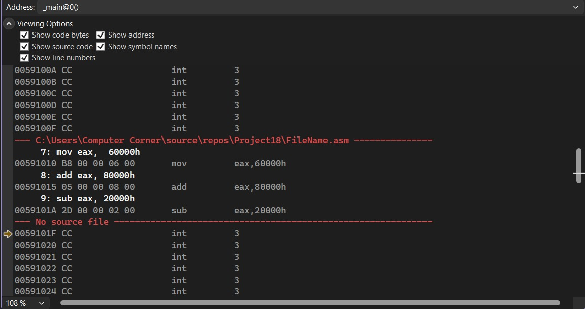

Exercise:

- Rewrite the given program for 16-bit register i.e. ax for the value of 600h instead of 600000h, 800h instead of 800000h, 200h instead of 200000h.

Program:

.686p
.MODEL flat, stdcall;
ExitProcess PROTO, dwExitCode: DWORD ; TO USE THIS PROTO, .MODEL MUST BE STDCALL
.CODE
main PROC
mov AX, 600h
add AX, 800h
sub AX, 200h
main ENDP
END main

Output:
